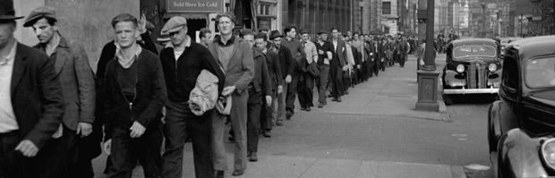
WHERE DID ALL THE MONEY GO?
During the 1920s, most people in the United States enjoyed prosperity. But the affluence of the Roaring Twenties began to evaporate in 1929. By 1932, 12 million people were out of work. The American economy went from unprecedented economic growth in the 1920s to unprecedented misery in the 1930s. The Mystery is why?
Among the major reasons for the Great Depression include overproduction, restrictive trade policy, speculation in the stock market based on buying stock on credit, problems with the banking system, and tax policy. What began as a mild recession following a lengthy period of economic expansion soon became a depression. By the 1930s the amount of money in circulation had drastically decreased.
We will need to become detectives, gather clues and solve “ How did the great depression happen?”

PROCESS
Part 1
1.) Read “Whatdunit”” — Where Did All the Money Go? – #1
This article focuses on the contrasts between the 1920s and the 1930s. It poses the mystery that is central to this lesson: What caused the Great Depression?
2.) Go to http://www.infoplease.com/history.html the Almanac: History & Government website. You will need 2 partners. Each partner will select a five year interval (1920-1924, 1925-1929 or 1930-1935). Each partner will research their five years on the site and complete that section of Clue Sheet #1. Within your group you will share the information with one another until everyone has completed Clue Sheet #1.
3.) As a group think about and answer the following questions and be prepared to discuss with the class:
- What was happening to consumer prices during the 1920s? 1930s?
- Which groups would be most negatively affected by the changes in prices you identified?
- What was the trend in the unemployment rate in the 20s? 30s?
- Why was that occurring in the 30s?
- What was happening to spending by the federal government in the 20s? 30s?
- What events might explain government spending patterns in the 20s and 30s?
- What events occurred in the U.S. or the world that would affect peoples' lives directly or indirectly in the 20s? 30s? Select events that seem especially important and explain their impact.
Part 2
  - Use the same groups of three. Each partner will complete 1 section of Clue Sheet #2
1. Labor and employment
2. Poverty and Income
3. Economy and Government)

When you have finished your section, share your answers within your group until everyone has completed Clue Sheet #2.

  - Utilizing the web sites and questions on the sheet, you can suggest how these factors contributed to the Great Depression. The Clue #2 sites deal with labor and employment, poverty and income, and the economy and government. When you have finished, share your answers
  - Now as a group and then as a class answer the following questions:
a.) How are the overall employment trends related to income?
b.) Why was farm income depressed throughout the 1920s?
c.) What caused the trends in government spending during this time?
Part 3
  - Using the same groups of three. Each member of the group will read 1 of the 3 clue sheets. Each clue sheet contains an article and a series of questions. Students should read their article and answer the questions. Students in the group then share the information with each other.
Clue Sheet #3a - Henry Ford Begins Production of the Model T in Highland Park
Clue Sheet #3b - The Federal Reserve Board
Clue Sheet #3c - The Stock Market Crash of 1929

  - After you've shared the information you've collected, answer the following questions:
- How did innovation and Ford's leadership in employee relations fuel the economic growth during the 1920s?
- What role did the Federal Reserve System play in this era?
- How did the stock market crash accelerate the economic slide into the Great Depression?
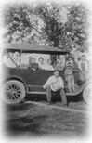
Part 4
1.) Brainstorm about what businesses that began or expanded because of the mass production of the automobile. (These would include suppliers to both industries, capital equipment manufacturers, producers of complementary goods, and the construction industry.)
2.)Take a look at the following definitions and descriptions:
- Suppliers provide all the parts and materials needed to make a car and the car companies assemble those parts.
- Capital goods are the factory, tools, and the machinery used in production.
- Complementary goods are ones that consumers demanded because cars became the main means of transportation.
- Examples of these would be roads, gas stations, hotels, restaurants, repair shops, housing, etc.
3.) Go to http://lakeviewushistory.weebly.com
  - go to current unit
  - go to unit 5 interdependence web
  - complete activity online

After you've completed the activity, be prepared to discuss the following:
- What types of jobs does any business need to function?
- When workers in these jobs earn income from their jobs, what are the three major uses they make of their income?
- When income declines, what happens to the three 'things' you identified in the previous question?
- When demand for cars declined in the late 20s, what kinds of companies business declined?

ASSESSMENT ACTIVITY
- Create an Interdependence Web that shows the businesses related to the personal computer revolution. Make sure you've completed the Interdependence Web Activity in part 4 so that you know what your final product should resemble.
- Explain the relationships among these businesses and predict what would happen in the economy if interest rates rose by 5 percent you or more.

