90PUSH (Unit 7, # 2) Name ____________________________
Date __________________ Stu#______

The Red Scare, Eisenhower, & the Cold War

I. In the 1950s, Cold War tensions led to anxiety & fear in America:
A. The _____________ dominated Eastern Europe & _____________ fell to communism
B. The __________________________ almost led to a full-scale war with China
C. The U.S.-Soviet atomic arms race led to fears of a ___________________________
D. The discovery of Soviet spies in the U.S. led to a new __________________________
II. McCarthyism & the Red Scare
A. During the Red Scare, the gov’t became concerned about the growth of communism in America
1. The ______________________________ Board was created to investigate & dismiss “disloyal” gov’t employees
2. The House ____________________________________ Committee (HUAC) investigated suspected communists in the _____________________ & other industries
3. In 1947, numerous Hollywood writers & executives were investigated by _____________; 500 were blacklisted from the film industry & some were sent to prison for refusing to testify (the “__________________________”)
B. ___________________ fears in America were heightened by the discovery of ____________ working for the USSR:
1. State Dept employee ______________________________ who was eventually convicted of spying for the USSR
2. Ethel & Julius Rosenberg were convicted & executed for passing ______________________ secrets to the USSR
C. In 1950, Wisconsin Senator ___________________________ emerged as the leader of anti-Communism in the U.S.
1. He attacked Truman & the Democrats for allowing ________________________ to infiltrate the gov’t
2. He used public trials to make __________________________________________ against suspected communists in the State Dept & the U.S. military
3. McCarthy’s attacks lasted 4 years
a. But “_________________________” did not result in a single confirmed Communist or spy in the U.S. gov’t
b. McCarthy was briefly popular but by 1954, the Senate & American public grew tired of his ______________ techniques & McCarthyism faded
III. Eisenhower & the Cold War
A. In 1952, World War II hero Dwight Eisenhower was elected president
1. At home, he tried to promote the “___________________________” of the 1950s economic boom
2. In foreign policy, he took a _____________________________ against Communism
B. Eisenhower began a “_____________________” to fight the Cold War:
1. He invested heavily in new long-range ____________________________ (ICBMs)
2. In foreign policy, he used veiled threats of nuclear war to achieve his goals (called ________________________)
3. In case of a Soviet attack, the U.S. would use “_______________________________________” thus making the use of nuclear weapons ____________________ on either side
a. Americans were anxious by the threat of nuclear war & built ___________________________ for protection
b. In response to the threat of a Soviet ____________________ attack, Eisenhower pushed Congress to create the Interstate __________________________ System in 1956
i. 41,000 miles of divided highway to connect major U.S. cities
ii. In addition to helping promote trade & travel, these highways were vital to ___________________ cities during a nuclear attack
4. In addition to relying on nuclear weapons, Eisenhower increased the role of the ____________ in foreign policy
a. The CIA _____________ on foreign nations & carried out _______________________________ to weaken communist governments
b. The CIA led successful _________ in Iran & Guatemala and tried to _______________ Fidel Castro in Cuba
5. The Eisenhower Doctrine
a. After Stalin’s death in 1953, new Soviet leader Nikita ________________ began to challenge U.S. influence:
i. In 1955, the USSR formed the ________________________ alliance
ii. In 1956, the Soviet military violently suppressed an ___________________________ revolt in Hungary
iii. In 1956, the USSR began to make moves towards the Middle East
b. In 1957, the president issued the ___________________________________________, pledging the USA to protect the ________________________ from Communism
C. Sputnik & the Space Race
1. In 1957, the USSR launched the 1st space satellite, __________________________
a. People feared that the U.S. had lost its competitive edge
b. The National Aeronautics & Space Administration (________) was formed in 1958 to catch up to the Soviets
c. National Defense Education Act was created to promote _________, ____________, & technology education
2. The “_______________________” intensified the Cold War between USA & USSR
D Eisenhower failed to thaw the Cold War by the end of the 1950s:
1. In 1960, an American ______________ was ______________ over the USSR proving we were spying on Russia
2. He was unable to negotiate with the USSR ____________________________
3. Before leaving office, he warned against overspending on defense (“__________________________________ ______________________”)
IV. Conclusions: By 1960, the Cold War remained the major focus of U.S. foreign policy
A. Truman _____________________ communism in Europe while Eisenhower used the CIA & brinksmanship to limit _______________________________ influence
B. But, Americans remained __________________ due to McCarthyism, threats of ____________________________, & increasing gov’t spending on defense

Cold War Actions or Events under President Truman | Cold War Actions or Events under President Eisenhower
Which president was more “successful” during the Cold War? Why?

Telegram from Senator Joseph McCarthy to President Harry S. Truman, 1950

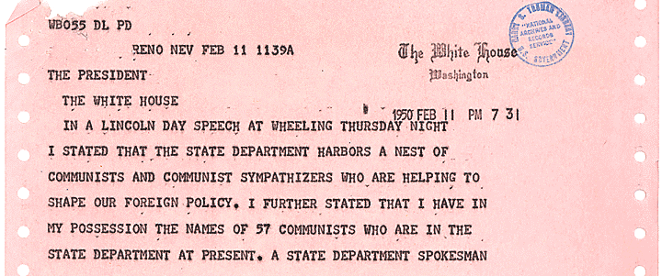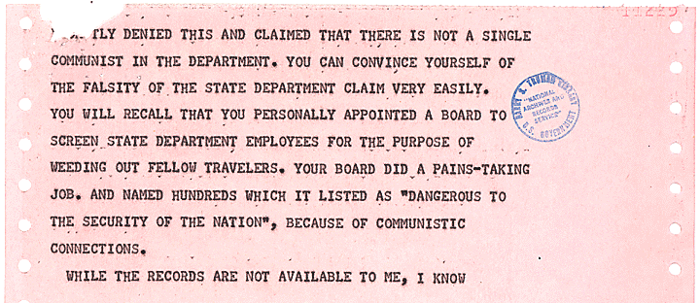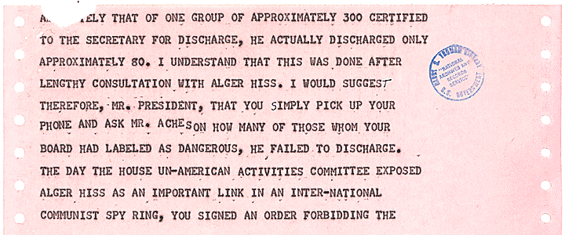
Notes from page 1 of the telegram

Notes from page 2 of the telegram

Notes from page 3 of the telegram

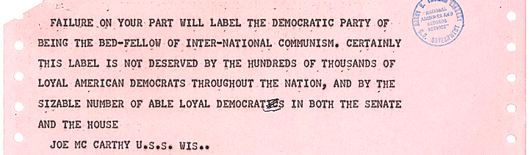
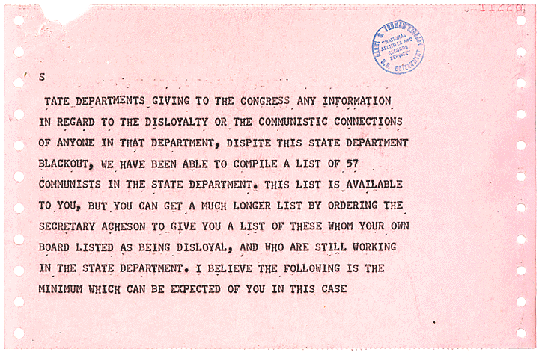
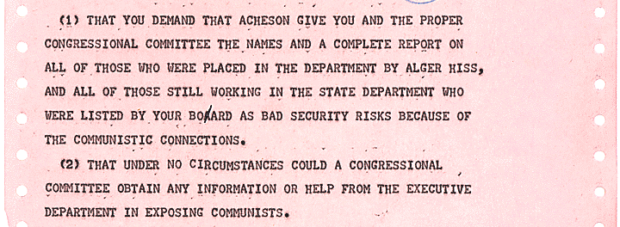
Notes from page 4 of the telegram

Notes from page 5 of the telegram

Notes from page 6 of the telegram

McCarthy Telegram Questions:
- What accusations does Senator Joseph McCarthy make in this telegram to President Truman? What do you think motivated McCarthy to send this telegram?

- How do you think the American people reacted when McCarthy made these accusations public in 1950?

- Assume the role of President Harry Truman. How would you respond to this telegram?

President Truman’s Response to the McCarthy Telegram, 1950
(The letter below was probably never sent)

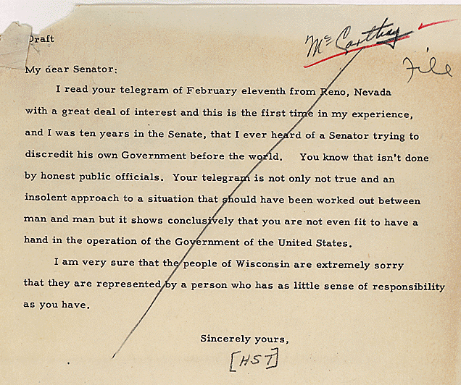

Truman Response Questions:
- How does President Truman respond to McCarthy’s accusations? What is the tone of this letter?

- Which side of this disagreement do you think most Americans would have chosen: McCarthy or Truman? Why?

- Examine the next document. What do all three of these documents reveal about American attitudes during the Cold War?



