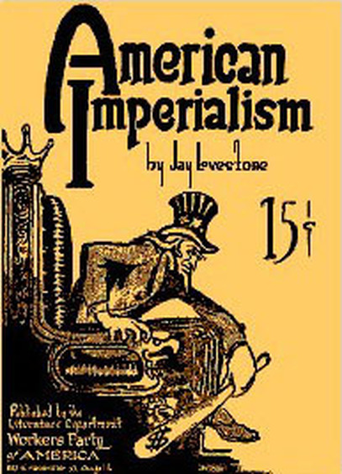
American Imperialism Webquest
Historical Context: By the late 1800s and early 1900s, the United States fulfilled its Manifest Destiny of extending its borders from sea to shining sea, reached new technological heights through the industrial revolution and had bustling cities that rivaled many of the imperial empires in Europe. Now, the U. S. wanted to expand its borders even further and yearned for an empire of its own. This progressive movement was a break from the traditional American foreign policy and was a reflection of the growing desire of many Americans to make their presence known on the world scene.
Imperialism Webquest: Today you are going to investigate American Imperialism. You will need to hold your mouse over the underlined link, press the control button and the click the mouse at the same time. This will take you to the web page where you will find your answers. You will need to read the entire section before answering. Make sure you answer each part of the questions in full.

Area 1 Expansion Over Seas
- a.) Who was Alfred Thayer Mahan,

b.) and what was his argument for why the United States should have a strong Navy?

Scroll down the Letter to the Emperor section of this web page to answer questions 2-5.

2) Extended Response: What nation was the strongest imperial power during this time period? Why?
3) What was the purpose of Commodore Perry’s trip to Japan in 1853?
4) What did the Japanese agree to in this letter from U.S. President Fillmore? Why?
5) Why did the United States Navy come back with eight warships in February 1854?
6) a.) In March of 1867 the United States purchased Alaska from the Russians for how
much?

b.) Why was this purchase known as Seward’s Folly?
c.) Why did this perception change in the 1890s?

7) Here is some further information about Seward's Folly and the purchase of Alaska!
a.) What Russian signed the Treaty of Purchase?
b.) What weapon was used against President Johnson?

Scroll down to Footholds in the Pacific of this page to answer questions 8 - 18
8) In the Pacific which islands lie closest to the American Mainland?
9) Pearl Harbor is on which island?
10) What are Kanaka?
11) What did the Americans dominate?
12) What does the slogan "Hawaii for Hawaiians" mean?
13) What organization plotted revolution?
14) What was the Hawaiian king’s name? What happened to him?
15) What was the person’s name who assumed the throne after the King?
16) Who was Sanford B. Dole?
17) What President had reservations about taking over an independent country?
18) What President refused to give Hawaii back to the Hawaiian’s?
Area 2 Asia
- Who was John Hay?

- What was the Open Door Policy and why did John Hay want to implement this policy? Be sure to define spheres of influence in your explanation.
3) What countries were involved in this agreement?
4) Explain fully the Boxer Rebellion.

